**Develop The Web Application Using Node-RED**

|  |  |
| --- | --- |
| **Date** | 17 DECEMBER 2022 |
| **Team Id** | PNT2022TMID08806 |
| **Title** | Hazardous Area Monitoring for Industrial Plant using IoT |

NODE RED FLOW

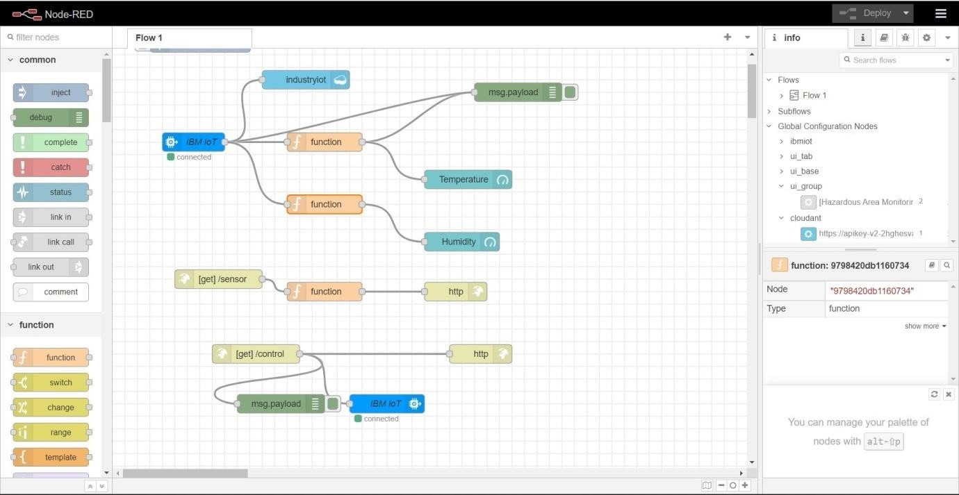

**Function blocks**

